The Improvement Plan

|  |  |  |  |
| --- | --- | --- | --- |
| Project Name | Website Development for Record Keeping | | |
| Project Manager | Tony White | Sponsor | Sydney Wildlife Board |
| Team | …. | | |

|  |
| --- |
| What are we trying to accomplish? |

# Description of the Current Situation

## Project in Context: Overview

Sydney Wildlife is a volunteer organisation dedicated to the rescue, care and rehabilitation of native fauna in the Sydney Metropolitan area.

We provide educational and community services as part of our existence and this is also an important role in the long term survival of native animals

The organisation has been in existence for 15 years with approximately 400 volunteers managing around 12500 calls per year from members of the public (MoP) for either;

* requesting advise about native animals or
* requiring a volunteer to go out and rescue a native animal

We run a 24/7 service with an office call centre in day hours and an after-hours service run from volunteers homes.

We are a 100% volunteer organisation and receive no funding from government agencies. As with any volunteer organisation we have a diverse range of staff and skillsets.

Our Strategic Plan was developed by the current board:



B. Animal Records Keeping

G. Website and IT Solution

Figure 1: Sydney Wildlife’s Strategic Plan

Parts of this is to modernise the predominately paper-based office environment that currently exists and improve on animal records keeping.

All animal records are currently recorded on paper forms and then transferred into a MS Access Database. A website was partially developed by a member based on this database, but done with minimal consultation to what functionality was required by the organisation. The person then left the organisation. This approach has happened several times during the life of the organisation with various members.

## Problem Statement

One of the most significant problems in our organisation is our ability to efficiently and effectively manage our data. Figure 2 pictorially represents the current problem and consequences:

**Consequence**

**Problem**



Figure 2: Problem and Consequences Statement

Our organisation is licenced under National Parks and Wildlife Service (NPWS) with a requirement to keep and maintain accurate animal records of our activities and report these on an annual basis.

It is currently difficult to collate the data for compliance reporting with significant animal fates unknown and/or missing, The average for the last 5 years:

* 12,500 called to the office per annum
* 7,700 rescues are undertaken per annum
* The fate of 49% of animal callouts remain unknown (~3800 animals per annum)
* Currently 26% (2015 per annum) of animal callouts are reported as a successful outcome (return animal to the wild)
* There is approximately a 10% return rate on the Animal Records Form (Fate Form) from members undertaking rescues

Animal Fates are collected either by:

* Via the office (members phoning in to say what happened to the animal, or office worker recording directly)
* Filling out Animal Records Form

Animal fates can be: released, in care, euthanised, died etc.

The data was obtained from the MS Access database which has been running since 2003, keeping this up-to-date is a time consuming exercise as the information is typed in from either the call record form (created in the office via MoP call), with additional information provided from members the Animal Records Form. Consequently it is missing large tracts of final animal data due to no available information plus significant time is spent on duplication management

Expanding on the need to improve our data management on animal fates, a greater holistic view was taken to include the wider data management issues we currently face.

# Link to External Customer: Outside-In Thinking

This section covers our three key external customers

## National Parks and Wildlife Service (NPWS)

One of our key licencing requirements is accurate annual reporting to NPWS who at this stage are provided the bare minimum of information and aren’t questioning the accuracy of what we supply.

We are required to provide detailed information in accordance to:

*NSW Office of Environment and Heritage: Code of Practice for Injured, Sick and Orphaned Protected Fauna Section 14 Records Keeping*. Which currently we fall short of as an organisation.

<http://www.environment.nsw.gov.au/resources/wildlifelicences/110004FaunaRehab.pdf>

NPWS have recently started to undertake auditing of Wildlife Carer groups with adverse impacts. The first audit of NATF (Hunter Wildlife) resulted in a loss of their coverage area and consequently 48 volunteers. NPWS unfortunately haven’t been forthcoming in specific areas of concern for their decision, though data management is suspected to be one critical factor. Improving our data and demonstrating a robust process, I predict will be essential to keeping our licence and hence our ability to exist as a wildlife organisation.

## Community Groups

Community groups, councils and universities sometimes request data for studies and human/environmental impacts. These requests are getting more regular and we struggle to provide meaningful information to them (recently requested info on powerful owls). The ability to easily supply say animal callouts and fates in a council area or kangaroo kills on a stretch of road will provide valuable information to improving animal welfare in our environment.

## Members of Public (MoP)

Members of Public generate the majority of enquiries and subsequent rescues. It is vital for our brand that they have a good experience when dealing with our organisation; both while dealing with us on the phone and with the face-to-face interaction of our rescuer who attends the site.

We want MoP’s to recommend us to their friends and additionally as a 100% volunteer organisation, a sizable amount of donations come from this sector.

In the context of data, we often receive follow-up calls to ask how the injured animal they found and called us out for is doing. With the current paper-based system, we need to trawl through folders of paper to find the original call, which is time consuming and once found, often does not have the fate of the animal. Having this information at your fingertips will enable instant answering of the enquiry.

# Key Linkages and Impacts: Systems Thinking

## High level Linkage of Process (LOP) for Animal Records Keeping

The end to end process for managing records is currently paper-based, Figure 3 shows the office workspace where calls are taken and the key tools we use to capture calls and find rescuers to send out.

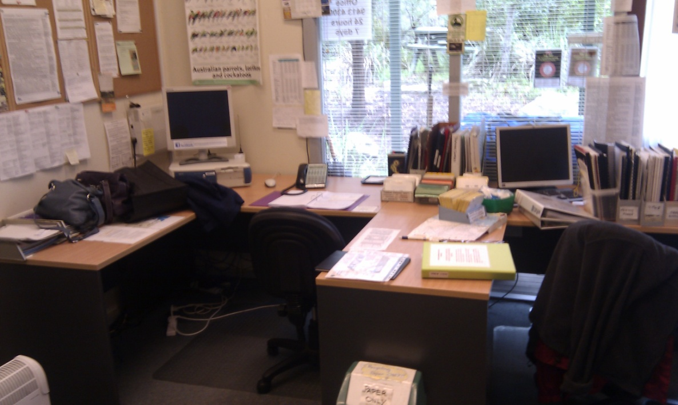

Call Record Folder with pages uniquely numbered with Record Number

Card system for finding members to call for rescues

Figure 3: Office Set-Up

Due to the intended modernising of our system, each area will be looked at in detail and will either computerise the existing process, and/or improve the process.

## Stakeholder Analysis

Teams, stakeholders and individuals were identified of members likely to be impacted by the changes the most. As it is a significant move from what we do today, it is expected all 400 odd members will be impacted to some degree.

|  |  |
| --- | --- |
| Name | Information |
| Project Team | Keen, volunteers with busy outside lives |
| Cale (Programmer) | Taken on programming pro-rata, busy with work and teaching TAFE, enthusiastic about project but also time poor |
| SW Board | Very keen to get an e-system working and running.  Chair excited about prospect of going on-line |
| Office regulars | Generally frustrations with current paper-based system and double or triple handling.  May have concerns about moving to a different technology platform.  Difficult to find historical records when MoP’s ring in to see the fate of “their” animal. |
| Members using website | Mix of computer skills. Majority keen to move from paper system.  Bit of “heard it all before” about a computerised system |
| Statistics Officer (Trent Reed) | Part of improvement team, keen for a systems approach |

# Improvement Objectives

Part of the strategic plan was the development and implementation of a web-based system to manage Sydney Wildlife’s Membership and Animal Records in order to achieve:

* Increased return of completed records for Animal Fates from 49% to >95% to meet legislative requirements
* Reduced % non-closed status of calls at 45 days from 10% to 90%
* Greater detail and accuracy in records; understanding why the animal came into care in the first place
  + Recording Injury reasons increasing from X to Y
  + Recording Cause of injury increasing from X to Y
* Able to produce meaningful statistical reports easily about animal fates

Balancing Objectives

* Uptake of new Technology from Members

# Estimated Financial Business Impact

To Develop Cost of:

New Computers for Office with big screens

Development of Website

Platform of website

Ongoing costs for web platform

Time of development

|  |
| --- |
| How will we know a change is an improvement? |

A measurement plan was defined and summarised below:

Table 1: Improvement Measures

|  |  |  |  |  |
| --- | --- | --- | --- | --- |
| Measures Defined | Prediction | Current Performance | Goal | Achieved Performance |
| The return rate of completed animal records for rescued animals | 50% | 49% | >95% |  |
| The % of animal records with a “non-closed” status at 45 days | 20% | 10% | >90% |  |
| Increased detail of “injury” types for animal | 20% | X | Y |  |
| Increased detail of “cause” types for animal | 20% | X | Y |  |
| Uptake on web use for keeping animal records |  | nil | 75% within X months  95% of organisation after 6 months |  |
|  |  |  |  |  |
|  |  |  |  |  |
|  |  |  |  |  |
|  |  |  |  |  |
|  |  |  |  |  |

|  |
| --- |
| What changes can we make that will result in an improvement? |

# Outline of the Cycles

What is the key learning you want to achieve from carrying out a set of activities in this phase of the project – not what activity to carry out.

Rework these steps to show DMADV after initial baseline understanding

|  |  |  |
| --- | --- | --- |
| Phase 1 – DEFINE Cycle Objectives (Understand) | Output | When |
| Understand the Project – Define the Scope, High Level | Improvement Plan (Draft)  Solution Matrix  Timeline (estimated)  Stakeholders | 1/7/13 |
| Phase 2 – DEFINE Cycle Objectives (Understand) |  |  |
| Define Output Characteristics | Review of Legislation to define minimum requirements  Process Flow of Existing  Measurement Plan | 26/7/13 |
| Phase 3 – MEASURE Cycle Objectives (Understand) | Output | When |
| Is current system stable and capable | Bar Charts  Control Chart  Histogram | 26/7/13 |
| Phase 4 – DEFINE/MEASURE Cycle Objectives (Understand) |  |  |
| Define the needs of the Web Site | CTQ (Visioning)  Gap Analysis  Solution Platform  Priortise |  |
| Phase 5 – ANALYSE Cycle |  |  |
| Detailing the high level structure and interactions of the different parts | Key Functions  Security Settings  Members List  Tabs in Website – Layout  Search Engine |  |
| Phase 3 – DESIGN Cycle Objectives | Output | When |
| Building of Web |  |  |
| Phase 4 – IMPROVE - Develop Solution Cycle Objectives | Output | When |
|  |  |  |
| Phase 5 – IMPROVE - Test / Pilot Solution Cycle Objectives | Output | When |
|  |  |  |
| Phase 6 – IMPROVE – Implement Solution Cycle Objectives | Output | When |
|  |  |  |
| Estimated Project Completion Date: |  |  |
| Phase 7 – CONTROL – Manage new process, Post Implementation Evaluation Cycle Objectives | Output | When |
|  |  |  |